**LockedMe.com – Virtual Key for Repositories**

This document contains:

Demonstrating the product capabilities, appearance, and user interactions.

The code for this project is hosted at <https://github.com/AbhishekJha02/LockedMe.com>

The project is developed by Abhishek Kumar Jha.

## **Step 1:** Creating a new project in Eclipse

* Open Eclipse
* Go to File -> New -> Project -> Java Project -> Next.
* Type in any project name and click on “Finish.”
* Select your project and go to File -> New -> Class.
* Enter **LockedMeMain** in any class name, check the checkbox “public static void main(String[] args)”, and click on “Finish.”

## **Step 2:** Writing a program in Java for the entry point of the application (**LockedMeMain.java**)

**package** com.lockedme;

**public** **class** LockedMeMain {

**public** **static** **void** main(String[] args) {

// Create "main" folder if not present in current folder structure

FileOperations.*createMainFolderIfNotPresent*("main");

MenuOptions.*printWelcomeScreen*("LockedMe", "Abhishek Kumar Jha");

HandleOptions.*handleWelcomeScreenInput*();

}

}

## **Step 3:** Writing a program in Java to display Menu options available for the user (**MenuOptions.java**)

* Select your project and go to File -> New -> Class.
* Enter **MenuOptions** in class name and click on “Finish.”
* **MenuOptions** consists methods for -:
  1. Displaying Welcome Screen
  2. Displaying Initial Menu
  3. Displaying Business Level Operations available

**Step 3.1:** Writing method to display Welcome Screen

**public** **static** **void** printWelcomeScreen(String appName, String developerName) {

String companyDetails = String.*format*("*****************************************************\n"

+"*****************************************************\n"

+ "\n"

+ " Welcome to %s. \n"

+ "\n"

+ " Developer Name : %s. \n"

+ "\n"

+ "*****************************************************\n"

+ "*****************************************************\n",

appName, developerName);

System.***out***.println(companyDetails);

**Output:**

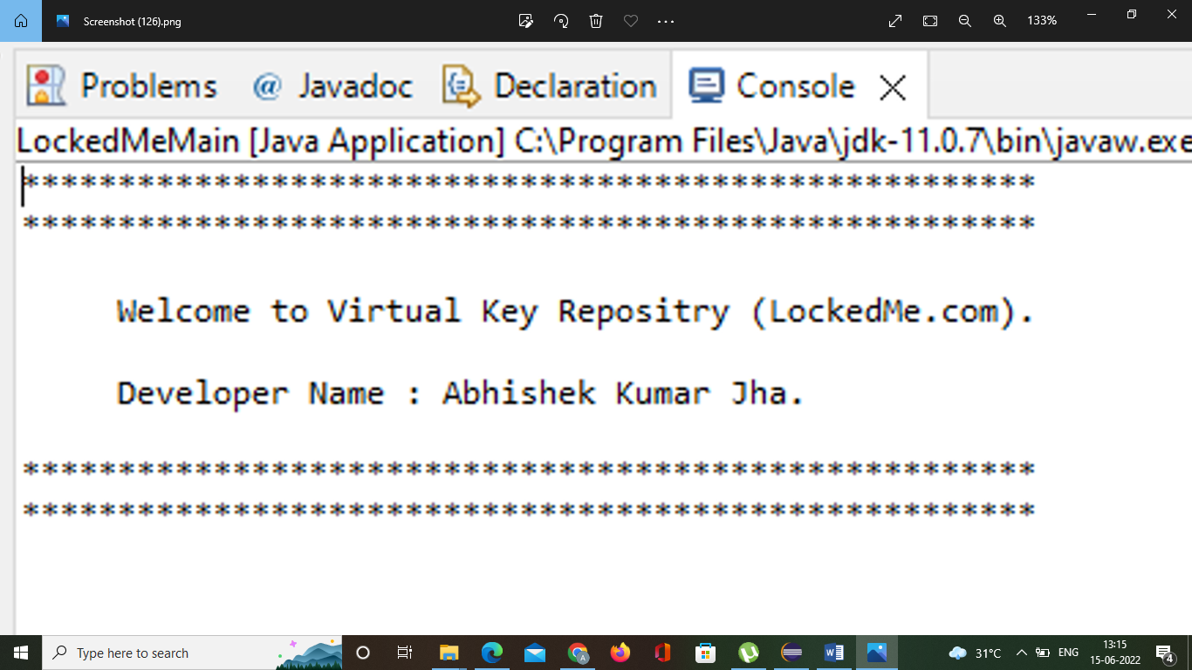

**Step 3.2:** Writing method to display Initial Menu

**public** **static** **void** displayMenu() {

String menu = "\n\n Select any option number from below and press Enter \n\n"

+ "1: Get All File Name From \"main\" folder in Sorted Manner\n"

+ "2: For Business Level Operations\n"

+ "3: Close the Applications\n";

System.***out***.println(menu);

}

**Output:**

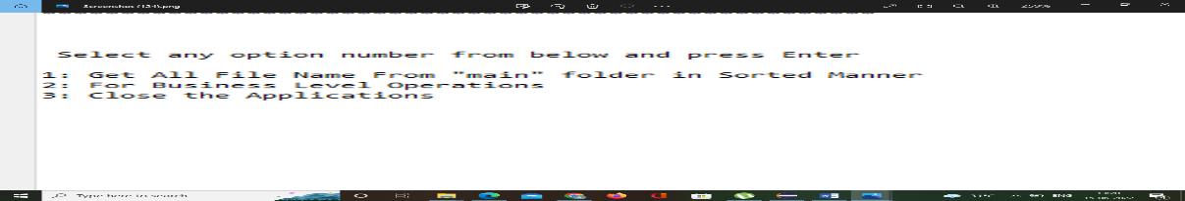

**Step 3.3:** Writing method to display Secondary Menu for File Operations

**public** **static** **void** BusinessLevelOperations() {

String fileMenu = "\n\n Select any option number from below and press Enter \n\n"

+ "1: Add a file to \"main\" folder\n"

+ "2: Delete a file from \"main\" folder\n"

+ "3: Search for a file from \"main\" folder\n"

+ "4: Go Back To Previous Menu\n" ;

System.***out***.println(fileMenu);

}

**Output:**

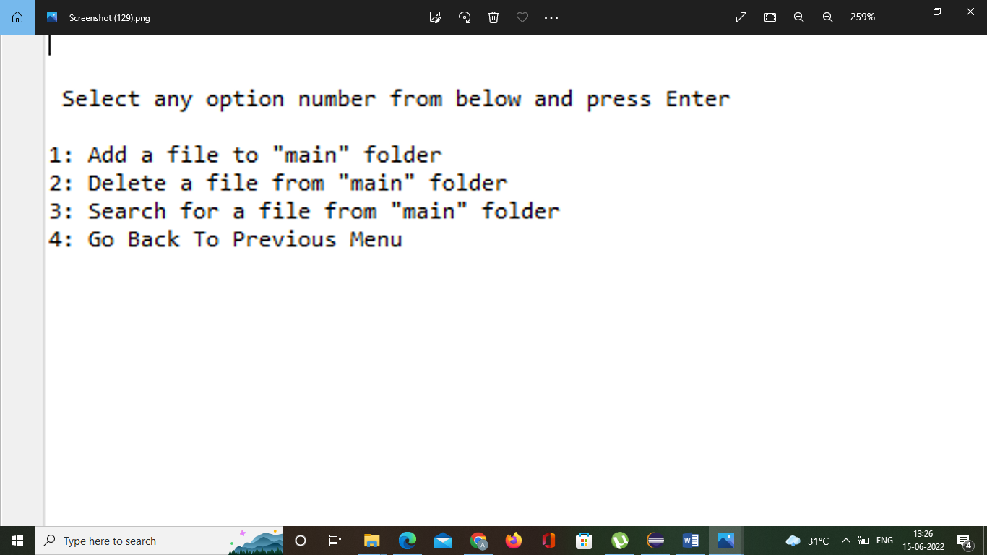

## **Step 4:** Writing a program in Java to handle Menu options selected by user (**HandleOptions.java**)

* Select your project and go to File -> New -> Class.
* Enter **HandleOptions** in class name and click on “Finish.”
* **HandleOptions** consists methods for -:
  1. Handling input selected by user in initial Menu
  2. Handling input selected by user in secondary Menu for File Operations

**Step 4.1:** Writing method to handle user input in initial Menu

**public** **static** **void** handleWelcomeScreenInput() {

**boolean** running = **true**;

Scanner sc = **new** Scanner(System.***in***);

**do** {

**try** {

MenuOptions.*displayMenu*();

**int** input = sc.nextInt();

**switch** (input) {

**case** 1:

System.***out***.println("Please Provide Directory Location");

FileOperations.*displayAllFiles*("main");

**break**;

**case** 2:

HandleOptions.*handleFileMenuOptions*();

**break**;

**case** 3:

System.***out***.println("Program exited successfully.");

running = **false**;

sc.close();

System.*exit*(0);

**break**;

**default**:

System.***out***.println("Please select a valid option from above.");

}

} **catch** (Exception e) {

System.***out***.println(e.getClass().getName());

*handleWelcomeScreenInput*();

}

} **while** (running == **true**);

}

**Output:**

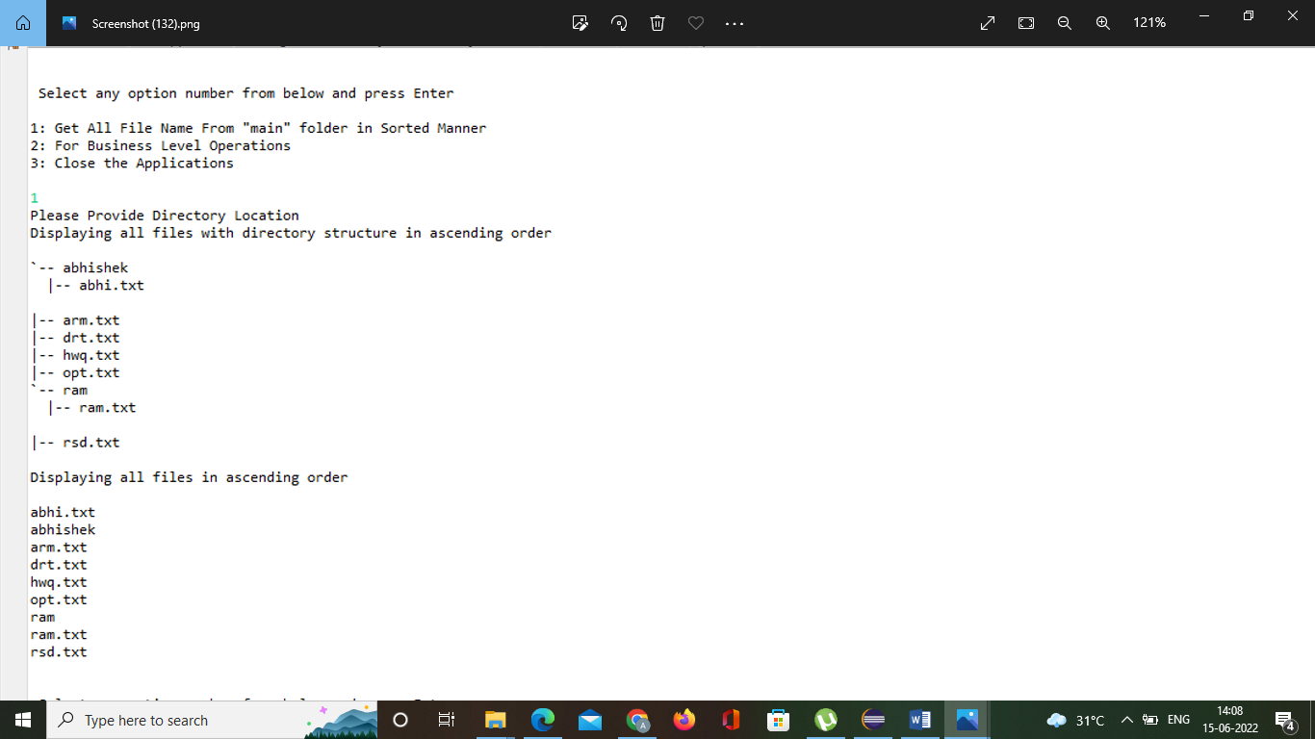

**Step 4.2:** Writing method to handle user input in Secondary Menu for File Operations

**public** **static** **void** handleFileMenuOptions() {

**boolean** running = **true**;

Scanner sc = **new** Scanner(System.***in***);

**do** {

**try** {

MenuOptions.*BusinessLevelOperations*();

FileOperations.*createMainFolderIfNotPresent*("main");

**int** input = sc.nextInt();

**switch** (input) {

**case** 1:

// File Add

System.***out***.println("Enter the name of the file to be added to the \"main\" folder");

String fileToAdd = sc.next();

FileOperations.*createFile*(fileToAdd, sc);

**break**;

**case** 2:

// File/Folder delete

System.***out***.println("Enter the name of the file to be deleted from \"main\" folder");

String fileToDelete = sc.next();

FileOperations.*createMainFolderIfNotPresent*("main");

List<String> filesToDelete = FileOperations.*displayFileLocations*(fileToDelete, "main");

String deletionPrompt = "\nSelect index of which file to delete?"

+ "\n(Enter 0 if you want to delete all elements)";

System.***out***.println(deletionPrompt);

**int** idx = sc.nextInt();

**if** (idx != 0) {

FileOperations.*deleteFileRecursively*(filesToDelete.get(idx - 1));

} **else** {

// If idx == 0, delete all files displayed for the name

**for** (String path : filesToDelete) {

FileOperations.*deleteFileRecursively*(path);

}

}

**break**;

**case** 3:

// File/Folder Search

System.***out***.println("Enter the name of the file to be searched from \"main\" folder");

String fileName = sc.next();

FileOperations.*createMainFolderIfNotPresent*("main");

FileOperations.*displayFileLocations*(fileName, "main");

**break**;

**case** 4:

// Go to Previous menu

**return**;

**case** 5:

// Exit

System.***out***.println("Program exited successfully.");

running = **false**;

sc.close();

System.*exit*(0);

**default**:

System.***out***.println("Please select a valid option from above.");

}

} **catch** (Exception e) {

System.***out***.println(e.getClass().getName());

*handleFileMenuOptions*();

}

} **while** (running == **true**);

}

**Output:**

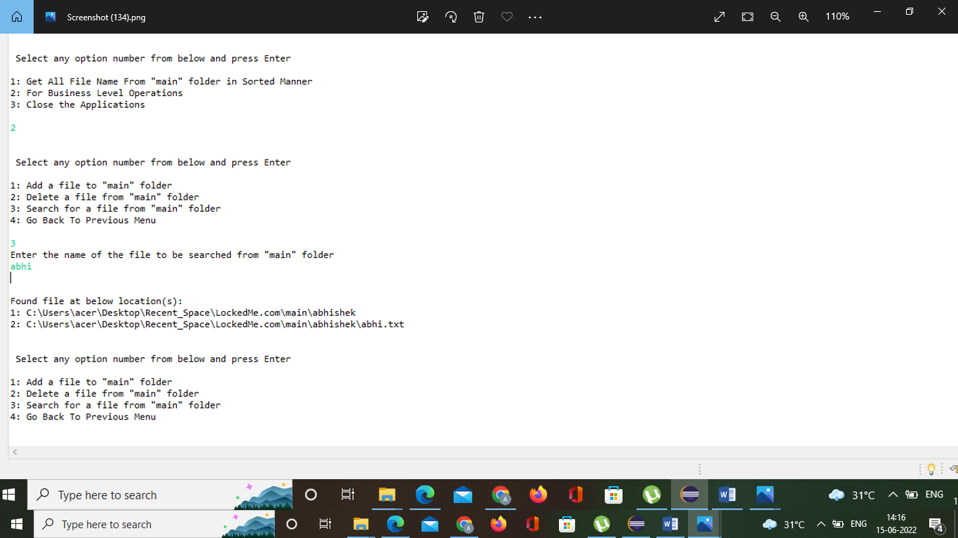

## **Step 5:** Writing a program in Java to perform the File operations as specified by user (**FileOperations.java**)

* Select your project and go to File -> New -> Class.
* Enter **FileOperations** in class name and click on “Finish.”
* **FileOperations** consists methods for -:
  1. Creating “main” folder in project if it’s not already present
  2. Displaying all files in “main” folder in ascending order and also with directory structure.
  3. Creating a file/folder as specified by user input.
  4. Search files as specified by user input in “main” folder and it’s subfolders.
  5. Deleting a file/folder from “main” folder

**Step 5.1:** Writing method to create “main” folder in project if it’s not present

**public** **class** FileOperations {

**public** **static** **void** createMainFolderIfNotPresent(String folderName) {

File file = **new** File(folderName);

// If file doesn't exist, create the main folder

**if** (!file.exists()) {

file.mkdirs();

}

}

**Output:**

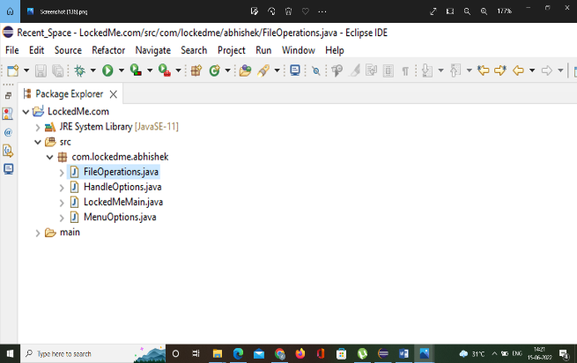

**Step 5.2:** Writing method to display all files in “main” folder in ascending order and also with directory structure. (“`--" represents a directory. “|--” represents a file.)

**public** **static** **void** displayAllFiles(String path) {

FileOperations.*createMainFolderIfNotPresent*("main");

// All required files and folders inside "main" folder relative to current

// folder

System.***out***.println("Displaying all files with directory structure in ascending order\n");

// listFilesInDirectory displays files along with folder structure

List<String> filesListNames = FileOperations.*listFilesInDirectory*(path, 0, **new** ArrayList<String>());

System.***out***.println("Displaying all files in ascending order\n");

Collections.*sort*(filesListNames);

filesListNames.stream().forEach(System.***out***::println);

}

**public** **static** List<String> listFilesInDirectory(String path, **int** indentationCount, List<String> fileListNames) {

File dir = **new** File(path);

File[] files = dir.listFiles();

List<File> filesList = Arrays.*asList*(files);

Collections.*sort*(filesList);

**if** (files != **null** && files.length > 0) {

**for** (File file : filesList) {

System.***out***.print(" ".repeat(indentationCount * 2));

**if** (file.isDirectory()) {

System.***out***.println("`-- " + file.getName());

// Recursively indent and display the files

fileListNames.add(file.getName());

*listFilesInDirectory*(file.getAbsolutePath(), indentationCount + 1, fileListNames);

} **else** {

System.***out***.println("|-- " + file.getName());

fileListNames.add(file.getName());

}

}

} **else** {

System.***out***.print(" ".repeat(indentationCount * 2));

System.***out***.println("|-- Empty Directory");

}

System.***out***.println();

**return** fileListNames;

}

**Output:**

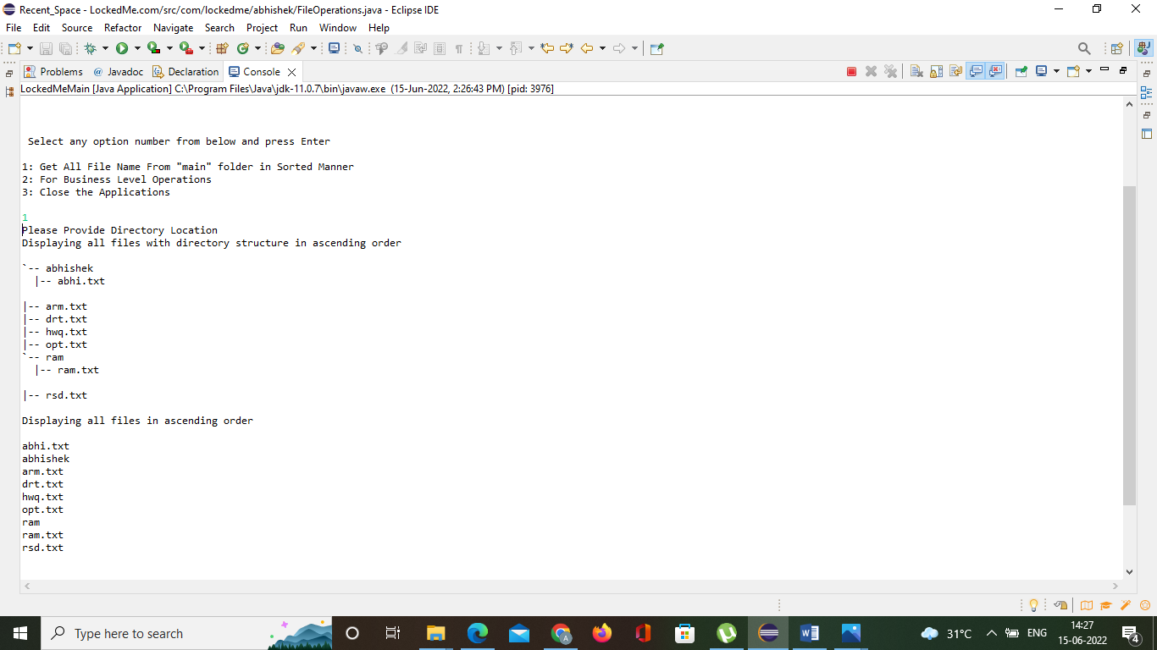

**Step 5.3:** Writing method to create a file/folder as specified by user input.

**public** **static** **void** createFile(String fileToAdd, Scanner sc) {

FileOperations.*createMainFolderIfNotPresent*("main");

Path pathToFile = Paths.*get*("./main/" + fileToAdd);

**try** {

Files.*createDirectories*(pathToFile.getParent());

Files.*createFile*(pathToFile);

System.***out***.println(fileToAdd + " created successfully");

System.***out***.println("Would you like to add some content to the file? (Y/N)");

String choice = sc.next().toLowerCase();

sc.nextLine();

**if** (choice.equals("y")) {

System.***out***.println("\n\nInput content and press enter\n");

String content = sc.nextLine();

Files.*write*(pathToFile, content.getBytes());

System.***out***.println("\nContent written to file " + fileToAdd);

System.***out***.println("Content can be read using Notepad or Notepad++");

}

} **catch** (IOException e) {

System.***out***.println("Failed to create file " + fileToAdd);

System.***out***.println(e.getClass().getName());

}

}

**Output:**

**Folders are automatically created along with file**

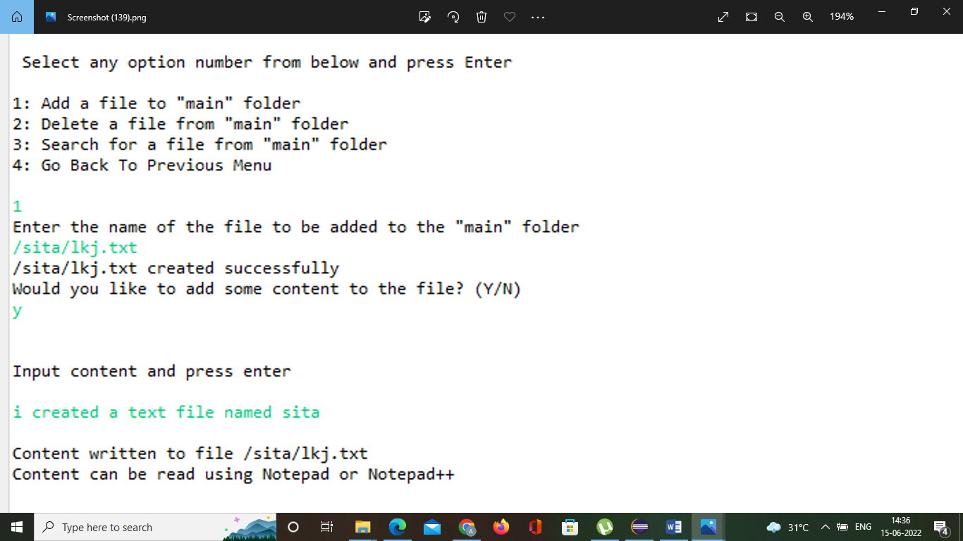

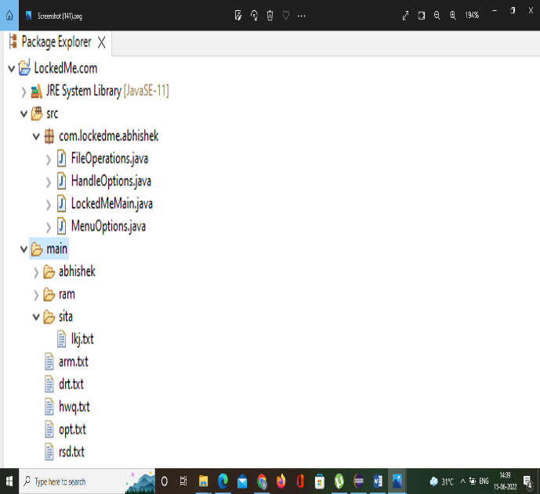

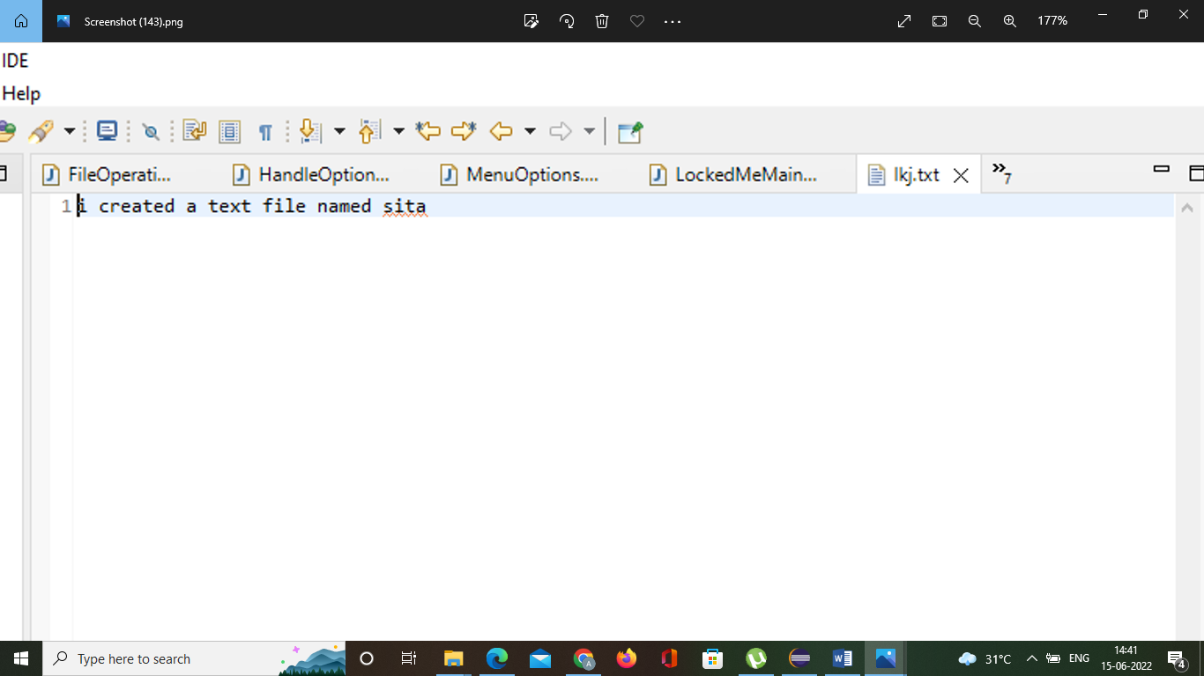

**Step 5.4:**  Writing method to search for all files as specified by user input in “main” folder and it’s subfolders.

**public** **static** List<String> displayFileLocations(String fileName, String path) {

List<String> fileListNames = **new** ArrayList<>();

FileOperations.*searchFileRecursively*(path, fileName, fileListNames);

**if** (fileListNames.isEmpty()) {

System.***out***.println("\n\n***** Couldn't find any file with given file name \"" + fileName + "\" *****\n\n");

} **else** {

System.***out***.println("\n\nFound file at below location(s):");

List<String> files = IntStream.*range*(0, fileListNames.size())

.mapToObj(index -> (index + 1) + ": " + fileListNames.get(index)).collect(Collectors.*toList*());

files.forEach(System.***out***::println);

}

**return** fileListNames;

}

**public** **static** **void** searchFileRecursively(String path, String fileName, List<String> fileListNames) {

File dir = **new** File(path);

File[] files = dir.listFiles();

List<File> filesList = Arrays.*asList*(files);

**if** (files != **null** && files.length > 0) {

**for** (File file : filesList) {

**if** (file.getName().startsWith(fileName)) {

fileListNames.add(file.getAbsolutePath());

}

// Need to search in directories separately to ensure all files of required

// fileName are searched

**if** (file.isDirectory()) {

*searchFileRecursively*(file.getAbsolutePath(), fileName, fileListNames);

}

}

}

}

**Output:**

**All files starting with the user input are displayed along with index**

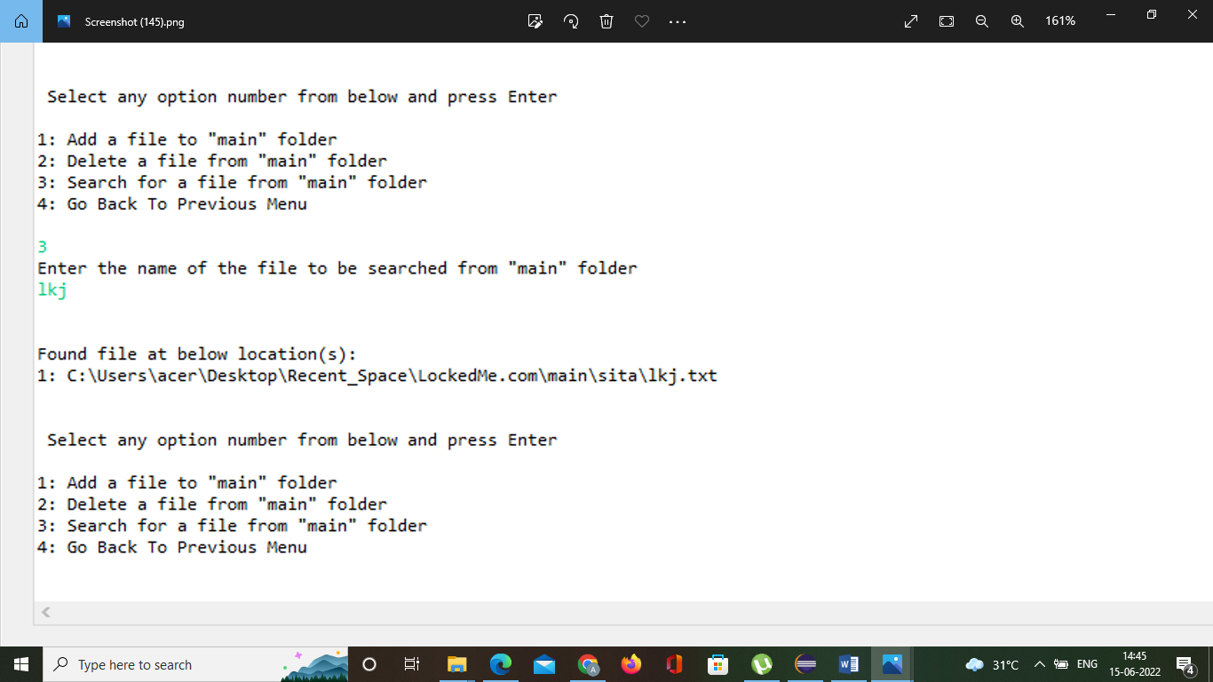

**Step 5.5:**  Writing method to delete file/folder specified by user input in “main” folder and it’s subfolders. It uses the searchFilesRecursively method and prompts user to specify which index to delete. If folder selected, all it’s child files and folder will be deleted recursively. If user wants to delete all the files specified after the search, they can input value 0.

**public** **static** **void** deleteFileRecursively(String path) {

File currFile = **new** File(path);

File[] files = currFile.listFiles();

**if** (files != **null** && files.length > 0) {

**for** (File file : files) {

String fileName = file.getName() + " at " + file.getParent();

**if** (file.isDirectory()) {

*deleteFileRecursively*(file.getAbsolutePath());

}

**if** (file.delete()) {

System.***out***.println(fileName + " deleted successfully");

} **else** {

System.***out***.println("Failed to delete " + fileName);

}

}

}

String currFileName = currFile.getName() + " at " + currFile.getParent();

**if** (currFile.delete()) {

System.***out***.println(currFileName + " deleted successfully");

} **else** {

System.***out***.println("Failed to delete " + currFileName);

}

}

}

**Output:**

To verify if file is deleted on Eclipse, right click on Project and click “Refresh”.

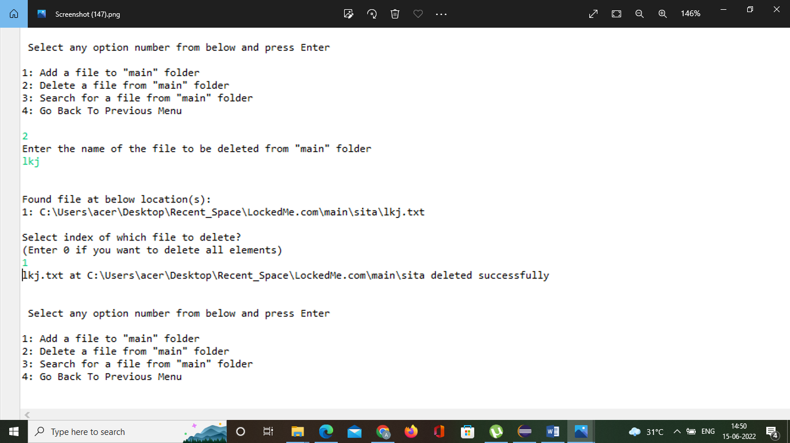

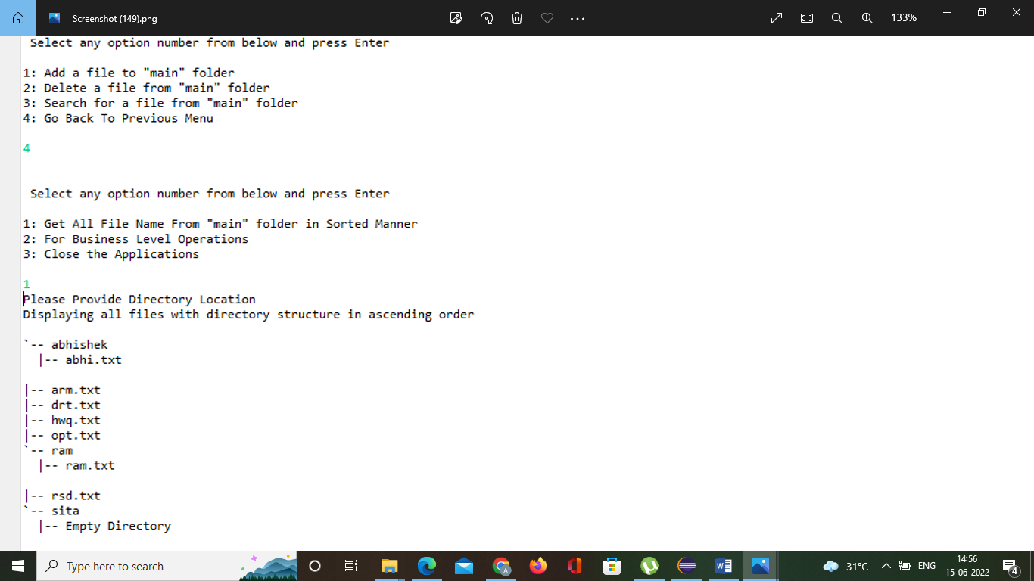

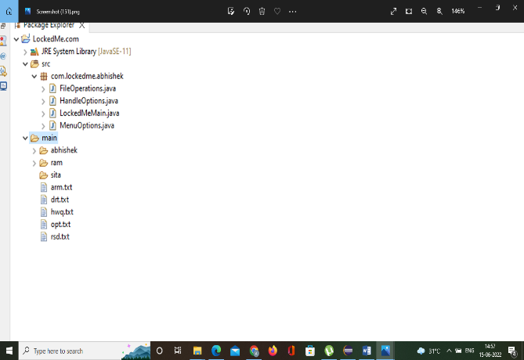

## **Step 6:** Closing Application :

**Output:**

